Design: Design: Directed Price Improvement
Overview:

Preferred Entitlements for Complex Orders would support ‘Preferred Market Maker’ (PMM) functionality for electronic Complex order that are traded with quoters/responders during either COA (Complex Order Auction) or COB (Complex Order Book) transactions.

Scope:

This document lists the changes made for the following features:

- PMM entitlements for

- Spread to Leg trade without auction
- Spread-to-Spread trade without auction.
- Spread to Leg with auction
- Spread to Spread with auction.

- Allow configuration of allocation strategy for:

- Spread to Leg COA Trade
- Spread-to-Spread COA Trade.

- Routing Property for Enabling/Disabling PMM for Complex Orders for a Class.

Design Details

New Constants added to AllocationContext

public static final String AVAILABLE_QTY_FOR_PMM_ALLOCATION = "AVAILABLE_QTY_FOR_PMM_ALLOCATION";
public static final String PMM_RFP_CAP_DETAILS = "PMM_RFP_CAP_DETAILS";
public static final String CAP_QTY_DETAIL_BY_PRODUCT= "CAP_QTY_DETAIL_BY_PRODUCT";

- AVAILABLE_QTY_FOR_PMM_ALLOCATION is the reference to retrieve the Original Auctioning Order Qty against which the PMM % is based off of from the context.
- PMM_RFP_CAP_DETAILS has reference to the MAP detailing BBO information for PMM firms used to give entitlements to RFP.
- CAP_QTY_DETAIL_BY_PRODUCT has reference to the MAP detailing BBO for PMM firms on the Legs.

Setting PMM information in the Order

PMM for Complex orders is applicable
- PMM is enabled for a class
- Affiliated Firm is specified in the Order or configured in the PDPMAssigment Routing Property for a Firm and Class
- Changes made to work flow steps to set the PMMs in the Order extensions, so on TE PMM allocation is made based on the PMM specified in the order.

Populating BBO of PMM firms

The cap details are populated before the start of the auction captured in BrokerProcessorSpreadHybridImpl.setAllocationContext().

The following 2 Maps are populated and maintained to ensure that the firm that is at the BBO at the start of the auction to be eligible for PMM entitlements:

- This Map contains cap details for trades that do not involve RFPs, defined as
  - HashMap<Integer, HashMap<String, Integer>> defining data as HashMap<ProductKey, HashMap<Firm, CapQty>>. The map of firm and Cap Qty is maintained for the legs and the spread product.
- The Map that contains cap details for RFP trade is of the format HashMap<String, Integer> defining data as HashMap<firm,CapQty>. For the RFPs to get PMM allocation, the PMM must be on top of book on either one of the legs or the COB, even if the COB is worse than the legs market.

Configuration of Allocation Strategy For COA Trade:

The allocation strategy for Spread-Spread and Spread-Leg COA trade has been made configurable as below.

Spread-Spread COA Trade:
This has been moved to a new method NTradeServiceImpl.createCOATrade(). The allocation Strategy configured in the Trading property for the spread product and AllocationTradeType “Spread Auction Trade (8)” will be used for Spread-to-Spread COA Trade.

Spread-Leg COA Trade:
NTradeServiceImpl.allocateLegTradables has been changed to pick the allocation strategy configured in the Trading property for the Leg product and AllocationTradeType “Spread Auction Trade (8)” to be used for Spread-Leg COA Trade.

AllocationComplexPreferredDPMStrategyElement : New element for PMMComplex Allocation:

This new element handles the PMM complex allocation for participants of a spread trade.

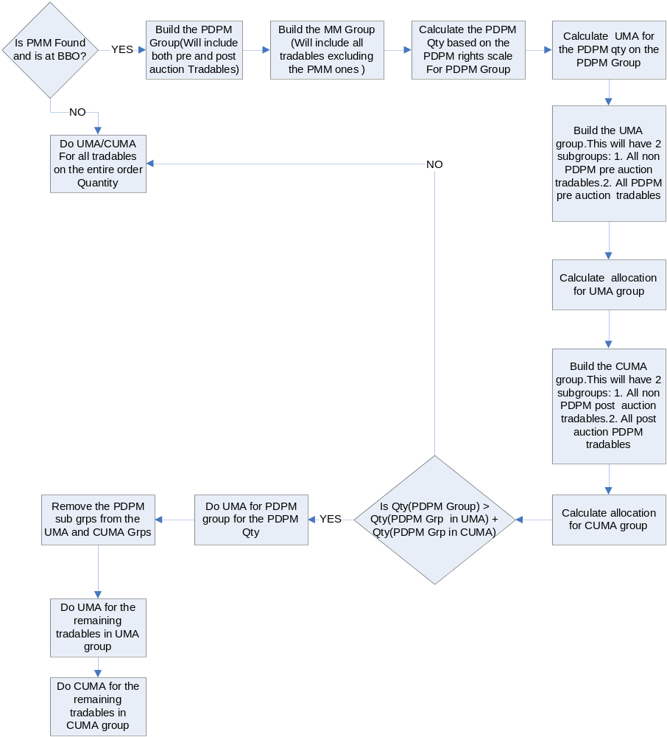

Files Changed:

1. Routing Property: PDPM Complex Eligibility. :

- PDPMComplexEligibilityHandler.java (new file)
- PDPMComplexEligibilityGroupBeanInfo.java (new file)
- RoutingPropertyMaskHelper.java
- RoutingPropertyServiceImpl.java
- PDPMComplexEligibilityGroup.java (new file)
- RoutingPropertyARHelper.java
- RoutingPropertyService.java
- RoutingPopertyFactoryHelper.java
- RoutingPropertyKeyHelper.java
- RoutingPropertyTypeImpl.java
- BasePropertyKeyTypeImpl.java
- PropertyServicePartialKeyClient.java

2. PMM Entitlements and Spread COA Trade Configuration

- WFStepSendToAbstractORD.java
- WFStepAppendPDPMDataComplexOrder.java
- PDPMExtensionsCompatibleHelper.java
- AllocationTradeContext.java
- AuctionInternal.java
- AllocationContextImpl.java
- BrokerProcessorSpreadHybridImpl.java
- AllocationCustomerStrategyElement.java
- AllocationPreferredDPMStrategyElement.java
- AllocationComplexPreferredDPMStrategyElement.java (New File)
- AllocationStrategy.java
- AllocationStrategyFactoryImpl.java
- AllocationStrategyImpl.java
- AllocationTradeContextImpl.java
- NTradeServiceImpl.java
- ParticipantListImpl.java
- TradeServiceImpl.java
- AuctionLocalImpl.java
- AuctionTransientImpl.java
- AllocationContext.java

Scripts
- None

Database
- None

SetContext
- None

XML/DTD

Homes/Services

ImplPlan
- None

PerformanceTestingProcedure
- None

TestingProcedure
- None

OperatorProcedure
- None

Fallback/Failover
- None

